Town of Spencer, Massachusetts

Two Zone Pressure System Project

By

Shira McWaters, P.E., Associate

Paul B. Howard, P.E., Senior Vice President

Donald Tata, P.E., President

Tata & Howard, Inc.

67 Forest Street

Marlborough, Massachusetts 01752

(508)303-9400

Presented at

130th Annual Conference

New England Water Works Association

Newport, Rhode Island

September 27, 2011

Abstract

In 2007, the Town of Spencer, Massachusetts received an Administration Consent Order from the Massachusetts Department of Environmental Protection mandating changes to their water treatment process, and the separation of the Town’s water distribution system into two pressure zones. This paper discusses the completion of this project in three phases. The System Study evaluated the conceptual design criteria needed for the two pressure zones and selection of tank sites. The Design Phase highlights permitting and design challenges encountered, and the Construction Phase discusses the overall final product, construction challenges and project successes.

Town of Spencer, Massachusetts
Two Zone Pressure System Project
By Shira McWaters, P.E.
Associate, Tata & Howard

Introduction
In 2007, the Town of Spencer Department of Utilities and Facilities received an Administrative Consent Order (ACO) from the Massachusetts Department of Environmental Protection (MassDEP). The ACO mandated the completion of several modifications to the Town’s existing water supply treatment process and existing distribution system. The mandated changes stem from the accidental release of sodium hydroxide (NaOH) into the distribution system in April 2007 at the Meadow Road Water Treatment Facility (WTF). The MassDEP required changes to the operation of the Town’s existing facilities and the separation of the distribution system into two pressure zones. This paper discusses key elements of the evaluation, design, and construction of the two zone pressure system.

Background Information
The creation of two separate pressure systems within the Town of Spencer had been an ongoing consideration for many years. Water main breaks, even on smaller diameter mains, often caused significant damage to infrastructure and roadways due to the excessive pressures. Several in-line valves were kept closed in strategic locations to divert flow along longer paths and smaller mains in an effort to reduce pressures in residential areas. In some areas within the distribution system, water mains on side streets were capped off and not connected to the larger transmission main coming from the treatment facility. Both residential and commercial customers located in the western portion of the distribution system required the use of pressure reducing valves. The MassDEP recommends that static system pressures generally be maintained between 60 to 80 psi, and not less than 35 psi. Water systems should also maintain a minimum pressure of 20 psi at ground level at all points in the distribution system under fire flow conditions. Additionally, pressures should not exceed 120 psi within the distribution system. The upper limit of operation is to reduce water lost from leakage. Due to the ACO received and the distribution operational challenges faced by the Town of Spencer, the Town proceeded with the Two Zone System Pressure Project.

The Town of Spencer is located in Worcester County along a section of undulating hills and valleys. The water supply sources are located along the valley floor at elevations of approximately 630 feet USGS. The Meadow Road Well is located west of Old Meadow Brook Road adjacent to the WTF. The well has an approved daily pumping volume of 1.74 million gallons per day (mgd). Water from this well is pumped through greensand filters in the treatment facility to a clearwell. A high lift vertical turbine pump is used to pump water from the clearwell into the distribution system. The Cranberry Brook Well is located east of South Spencer Road. This well has an approved daily pumping volume of 1.15 mgd. A vertical turbine high lift pump is used to pump water from this well into the distribution system.

Elevations increase from the valley floor located in the western portion of the system to the hills located to the east, as depicted on Figure No. 1. The highest elevations in the Spencer distribution system are in the vicinity of the 1.5 million gallon (mg) Moose Hill Tank, at approximately 1,070 feet USGS. The base elevation of the tank is 1,068 feet USGS and its overflow elevation is 1,120 feet USGS. The area served ranges in elevation from 630 feet to 1,040 feet USGS. The resulting pressures in the system range from approximately 35 pounds per square inch (psi) to 200 psi, and can exceed 250 psi when the high lift pumps in the Meadow Road WTF or Cranberry Brook Well are operating.

Figure No. 1 – Hydraulic Profile One Pressure Zone
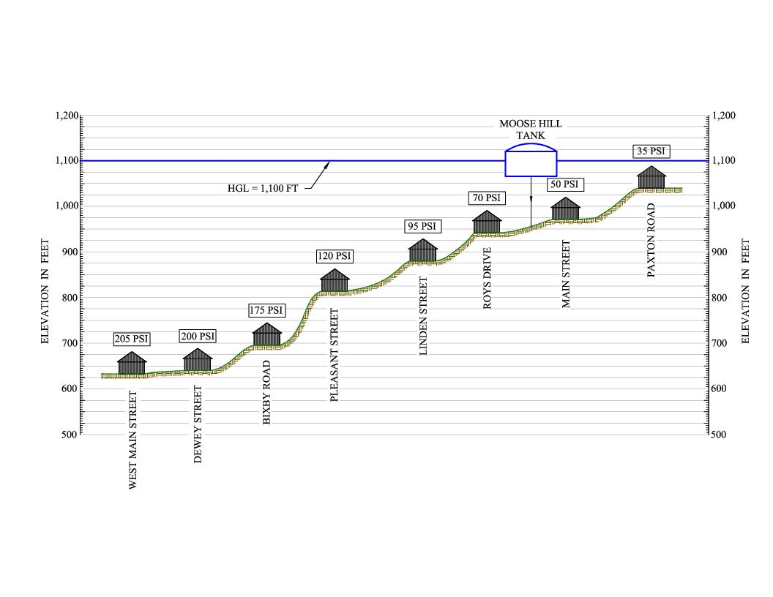
System Evaluation
In 2008, the Town of Spencer selected Tata & Howard to conduct a Two Zone System Pressure Study. The goal of the study was to determine the Town’s future water storage needs, locations within the Town suitable for a new water storage tank and booster pump station (BPS), and the optimal hydraulic grade line elevation for a new tank to serve a lower pressure zone. Criteria used for the evaluation included: resulting pressures within the two different zones, proximity to the existing infrastructure system, Town verses privately owned land, adequate elevations and open space to support a tank, potential impacts to the rural characteristics associated with the Town of Spencer, infrastructure improvements needed for each alternative, environmental impacts, and overall costs associated with the construction of these alternatives.

Using the MassDEP criteria of 35 to 120 psi, elevations were evaluated using the Moose Hill Tank’s overflow elevation and the lowest elevation to be served by the tank while maintaining an upper pressure limit of approximately 120 psi. This resulted in a minimum elevation of approximately 840 feet USGS, rather than the 630 feet USGS originally served. GIS mapping was used to develop a separation line using the established service elevation of 840 feet USGS. The boundary runs along a north/south axis approximately parallel to High Street, crosses Main Street and runs parallel to Elm Street and Temple Street, as depicted on Figure No. 2. This elevation was also used to establish the optimum overflow elevation of the new water storage tank that would provide pressures and fire flows to the new lower pressure Western Service Area (WSA). Using a minimum pressure requirement of 35 psi and a maximum elevation of 840 feet USGS, the resulting recommended overflow for the new tank was approximately 930 feet USGS. Based on existing elevations within the proposed WSA of 630 to 840 feet, the resulting pressure range would be between 35 psi to 130 psi. The resulting pressure range for the Eastern Service Area (ESA), serviced by the existing Moose Hill Tank, would be approximately 40 to 130 psi.

Population projections were developed for a 20 year timeframe and used to calculate storage requirements for both zones. Projected demands were incorporated into the Town’s hydraulic model and used to evaluate the percentage of total water demands that were represented in each service area using the separation line depicted in Figure No. 2. It was assumed that the overall population growth would be relatively uniform throughout the distribution system. Based on this criterion, approximately 44 percent of the total demand is represented in the WSA and 56 percent in the ESA.

The three components of water storage; equalization, fire flow, and emergency storage, were evaluated to determine the size of the new WSA water storage tank. The Town has back up power at the Meadow Road WTF that is adequate to meet the projected ADD for the WSA, and the design of the booster pump station included emergency power to meet the ADD of the ESA. Therefore, the emergency component was waived and not included in the storage calculation. Based on these criteria, the required storage for the WSA and ESA are summarized below:

Service Area | Equalization  mg | Fire Flow  mg | Emergency  mg | Total Storage  mg
WSA | 0.20 | 0.30 | - | 0.50
ESA | 0.26 | 0.30 | - | 0.56

The ESA has adequate storage in the 1.50 mg Moose Hill Tank, but it would be isolated from the Town’s water supplies; therefore, pumping via a new booster pump station was recommended for this tank. The WSA required the design and construction of a new 0.50 mg water storage tank with an overflow elevation minimum requirement of approximately 930 feet USGS. This overflow elevation was used to evaluate five potential locations for construction within the distribution system.

Using the selection criteria established with the Town, five locations within or near the east/west separation boundary were selected. During the selection process, it was of particular importance to minimize locations that would deter from the rural characteristics of the Town. GIS mapping was used to determine both private and public parcels available with adequate space to construct a tank and BPS, and each site was visited prior to recommendation to evaluate potential impacts on adjacent parcels and the rural nature of the Town. Of the five sites identified, three supported the construction of a ground level tank, including the Highland Street site, which was ultimately chosen.

Figure No. 2 – Two Pressure Zone Separation Boundary
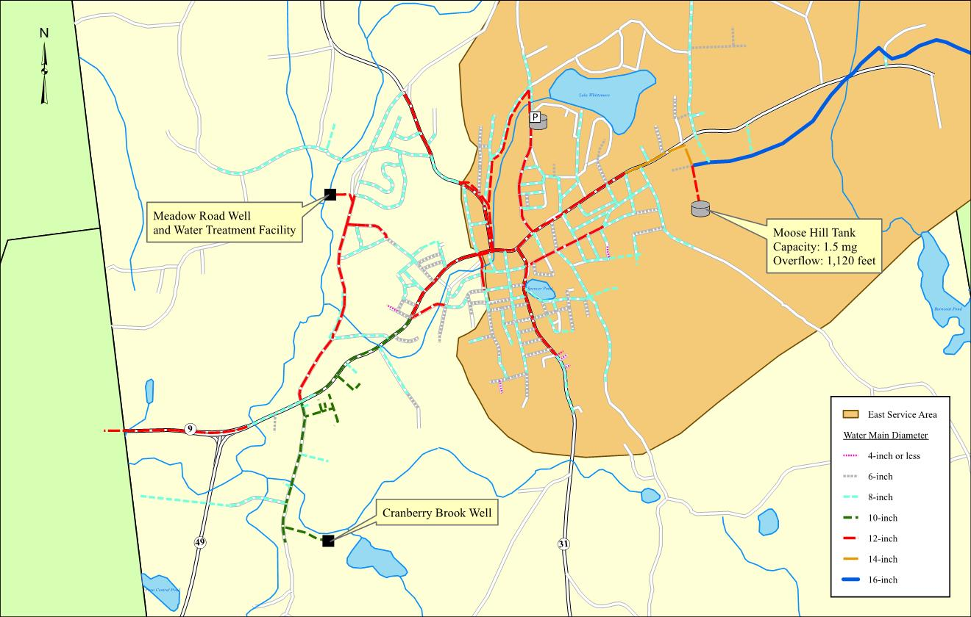

Utilizing the Town’s hydraulic model, the inherent fire flow capacities were evaluated under pre and post pressure zone configurations using the separation boundary depicted in Figure No. 2. Also, the evaluation considered the dead ends created as a result of the two pressure zone configuration. The majority of the fire flows evaluated did not differ from pre and post pressure zone configurations. Areas in which a deficiency was noted were slated for replacement or water from the adjacent pressure zone could be utilized to mitigate the deficiency through hydrants strategically located near this boundary. To address water quality concerns with the dead end water mains, new hydrants at specific locations were incorporated. In addition, the hydrants installed at the end of a dead end would aid during the Town’s flushing maintenance program.

The Highland Street site was the only Town owned property located near the East/West interface with adequate elevations to support a new water storage tank. Tight local and state deadlines needed to be met for the Town to qualify for state and federal funding. The Town was selected to receive Drinking Water State Revolving Funds (DWSRF). In addition, funding through the American Recovery and Reinvestment Act (ARRA) became available. Both the DWSRF and ARRA funding required a July 31, 2009 deadline for submission of the design and application. ARRA funding offered principal forgiveness on loans that was attractive to the Town. As a result, funding, tight deadlines, and eliminating the need to purchase land from a private entity were the deciding factors for the selection of the Highland Street site.

Design Phase
There were challenges associated with the construction of the new tank and BPS at the Highland Street site that were not observed at the other two sites. The site consisted of undeveloped woodlands rather than open fields. Constructing a roadway and clearing of the woodland within the footprint of the construction area would add to the cost of the project. Ground elevations at this site were the highest of the five alternatives ranging from 925 feet at street level to approximately 1,000 feet at its highest point. This ultimately added to the final overflow elevation of the tank and added an additional 10 psi operating pressure to the WSA. In addition, there was significant rock at this location which added to the overall site work costs of the project and design costs associated with a cast-in-place tank rather than a precast concrete tank, as originally envisioned. Although this site was located adjacent to existing infrastructure, it was in the ESA and required approximately 6,300 linear feet of dedicated water mains to connect to the WSA system.

A two chambered, 0.50 mg cast-in-place tank was designed. The overall dimensions of the tank are 80 feet by 100 feet with a height of 13 feet. Residents in the area voiced concerns during the permitting process that the tank would detract from the residential nature of the area. To address these concerns, the tank and booster pump station were set back approximately 100 feet from the road to provide a natural tree buffer between the site and the residential properties located adjacent to the site. The resulting overflow is 957 feet USGS. This portion of the project required review by the Spencer Planning and Zoning Boards, and filing of a Notice of Intent based on the stormwater component associated with new development and impervious area.

Approximately 6,300 linear feet of new 12-inch diameter transmission main was designed to interconnect the new water storage tank to the WSA. Since the transmission main required construction parallel to existing water mains that service areas within the ESA, the replacement of approximately 7,500 linear feet of water mains were included in the overall design of the project. The existing 6 and 8-inch diameter water mains are unlined cast iron (approximately 1930’s) and had experienced breaks in the past. The likelihood that the older mains would break during construction was high. In addition, replacement of these water mains while the streets were disturbed for the construction of the 12-inch transmission main eliminated the need to reopen the street for future repairs or replacement, and minimized disturbance to the area residents.
An additional 600 linear feet of 12-inch diameter water main was added to the final design along Elm Street. At the time of the design, the Town was replacing a section of older water main on Elm Street (from Pearl Street to Valley Street) and additional lengths along this street were included. At the time of bidding a total of 13,900 linear feet of water main was incorporated into the design.

The overall operation of the two zone pressure system does not differ significantly from the former operation, just at a lower hydraulic grade line elevation for the WSA. The overall reduction in head is approximately 160 feet or 70 psi, reducing pressures from over 200 psi in the vicinity of West Main Street to approximately 140 psi as depicted in Figure No. 3. The high lift pumps at the Meadow Road WTF and the Cranberry Brook Well turn on and off at predetermined water levels in the new Highland Street water storage tank via a new SCADA system incorporated into the design. The WTF remains as the primary facility and the Cranberry Brook Well is considered a back up source. The water level in the Highland Street Tank is transmitted to the WTF with a new radio telemetry system and signals the pumps to either turn on or off.

Figure No. 3 – Hydraulic Profile Two Pressure Zones
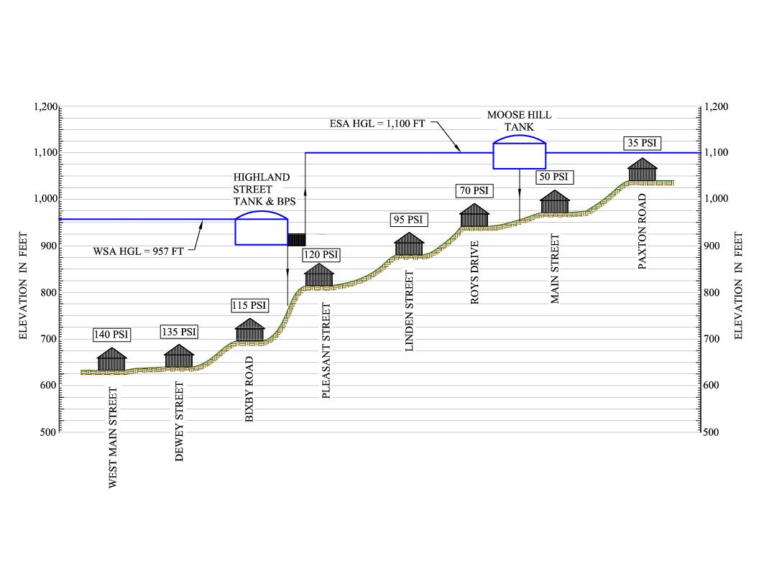

The pumps in the Highland Street BPS turn on and off at predetermined levels in the Moose Hill Tank. Water levels are monitored via a pressure transducer located in the adjacent vault and a signal is sent via radio telemetry back to the BPS.

The design phase had an aggressive schedule. The ACO helped the Town push this project not only through federal funding but through local procurement procedures and permitting. The design of the project started in April 2009 and required submittal to MassDEP by July 31. The four month schedule was tight and required firm deadlines to submit permit applications to get on local committee agendas and to receive approval. Communication was established at the very beginning of the design with the Department of Utilities and Facilities. The former Superintendent, Mr. Robert McNeil, III; System Operator, Mr. Gregory Karpowicz; and former Town Planner, Adam Gaudette were key in coordinating meetings with the local agencies and to convey the urgency to move the permitting process and approval to meet MassDEP’s submission deadline. The Town’s Conservation Commission, Planning Board, Zoning Board, and Building Inspector were contacted at the start of the design to determine the permits needed, primary contacts, and meeting schedules. The results of this collaborative effort resulted in the successful completion of the permits before the July 31st deadline.

After the design phase was completed it was submitted to MassDEP for approval. Approval was received in November 2009 and the project was publicly bid in December 2009. The awarded contractor’s base bid was $6.17 million. There were seven additive alternates associated with paving which were added to the overall contract price. The resulting contract price was $6.71 million, which was within the appropriated funding.

Construction Phase
Prior to the start of construction, a meeting was held with the stakeholders, including the local Conservation Commission, Lake Street School Principal, School Busing Coordinator, Police and Fire Departments, as well as the contractor and the Department of Utilities and Facilities. The primary purpose of this meeting was to keep the stakeholders involved and to allow concerns to be addressed early in the process. Throughout the majority of the project, biweekly progress meeting were held and the various stakeholders were included in these meetings.

Construction began in February 2010 at the Highland Street Tank and BPS site. Prior to blasting, a comprehensive pre-blasting survey was completed within a 500 foot radius of the site. Typically, the survey is within a 250 foot radius, however, during the permitting process with the Zoning Board concerns were raised by the residents and the Zoning Board increased the survey radius to 500 feet. In addition, the contractor was required to notify the Lake Street School 24 hours in advance of blasting. The Department of Utilities and Facilities kept an open line of communication with residents to discuss the project and answer their questions. This was key throughout the project and ultimately resulted in limited complaints.

Throughout the project, specific DWSRF and ARRA reporting requirements needed to be met that added to the challenges of managing the project. They included specific Buy American Certification that needed to be submitted with each payment request signed by the contractor and a separate form signed by the Town. Weekly engineering and contractor hours and costs, including all subcontractors and minority business enterprise (MBE) and woman business enterprises (WBE) were required for submission to MassDEP through Survey Monkey. The Survey Monkey information was completed weekly by the engineer and forwarded to the Town for submission to MassDEP by Friday afternoon. This required full conformance to completing time records each week for each member of the project team. To minimize problems associated with multiple parties trying to complete the required DWSRF and ARRA invoicing forms, it was determined that all payment requests, including associated invoicing from the contractor, Police and Fire Departments would go through the engineer. Preparation of the payment request was more involved than a standard construction project and required the use of the appropriate DWSRF forms and ARRA reporting. Preparing these forms required direct communication between the contractor and the engineer, and included the contractor’s costs, costs associated with the MBE/WBE’s, and execution of the payment request and the DWSRF BMF2000 form, and Buy American Certification. Invoices from the local Police and Fire Departments were also sent to the engineer for inclusion in the payment request as well as the MBE/WBE’s invoicing associated with the construction services contract.

Construction challenges associated with this project were relatively limited for a project of this size. There was significant rock located at the Highland Street Tank and BPS site, resulting in the removal of approximately 10,600 cubic yards through blasting. The contractor set up a rock crushing operation at a remote site within Town and the crushed rock was used on site. Concerns were raised by the local residents that large construction equipment would impact busing and commuting. To minimize these impacts specific trucking routes were developed and traffic was detoured to the extent possible. The original pavement condition of Wilson Street was poor and it quickly deteriorated further with the use of heavy equipment and truck traffic. Rather than providing permanent trench pavement the contractor completed a full depth reconstruction of the roadway which added to the cost of the project. Prior to construction, Dig Safe and the utilities were contacted to mark out the respective infrastructure. Due to limited information on the sewer lines, the contractor broke the sewer main during the construction of the water mains along Pleasant Street. National Water Main Cleaning Company was called in to video tape the sewer main in several areas so its location could be determined and avoided while constructing the water mains. A small section of the project required work along Main Street, the primary road into and out of Spencer. To minimize traffic impacts, the work was completed at night over a two week period. At one point, the water main on Main Street required shut down to allow the new main to be tied in to the existing main. The water main on Main Street is the primary water main that feeds the Moose Hill Tank. The Town anticipated back feeding this tank through the water main on Water Street. However, during this process, the lower half the system began to over pressurize, which resulted in several water main breaks. After field investigation, it was determined that the water main on Water Street dead ended and could not be used to back feed the Moose Hill Tank. In addition, the only path for the water to fill this tank was along the water main on Main Street which was off-line due to construction. An emergency hydrant to hydrant connection was completed that mitigated the problem until the Main Street work was completed. After the Town realized the limitation of having only one water main to fill the tank, a small section of water main was completed on Old Farm Road to serve as a secondary flow path to the tank. In addition, the water mains on Water Street and Valley Street were replaced and Water Street was interconnected to the water main on Valley Street, thereby providing another avenue for water to feed the Moose Hill Tank and the future Highland Street Tank.

The project is operating as a two pressure zone system. The total loan amount is $7.4 million and the principle forgiveness is approximately $1.4 million, 20 percent of the project. A total of 10,300 linear feet of 12-inch diameter water main and 7,500 linear feet 8 inch diameter water main was installed. Many of the new water mains eliminated hydraulic deficiencies and asset management concerns in the distribution system. Some locations were also considered critical since they supplied water to businesses in the downtown area of the distribution system; therefore, the new water mains improved performance and reliability to these areas. The Cranberry Pump Station was upgraded with new electrical controls, well pump, and Variable Frequency Drive (VFD). Modifications were completed at the Meadow Road WTF and a new radio telemetry system was constructed tying in the two tanks, BPS, and Watson Street Pump Station into both well sites. A new SCADA system was installed, allowing monitoring of all sites at the Meadow Road WTF. In addition, redundant pumps and parts were included in this project and the exterior rehabilitation of the Moose Hill Tank. Figure No. 4 depicts the general scope of construction associated with this project and Figure No. 5 shows the completed tank and booster pump station.

Keeping an open line of communication to the public, schools, and businesses was key in limiting complaints during construction. Additionally, the biweekly progress meetings between the Town, the contractor, and Tata & Howard were instrumental in the successful completion of this project. Special thanks is given to Mr. Adam Gaudette, Spencer Town Administrator; Mr. Gregory Karpowicz, Chief Water System Operator; Mr. Steven Tyler, Superintendent Department of Utilities and Facilities, and Mario Romania Jr., Project Manager at P. Gioioso & Sons, Inc. for providing respective insight relative to this project and cooperation throughout the project. Special thanks is also given to Mr. Robert McNeil, III, former Superintendent of the Department of Utilities and Facilities, for collaborating with the Town agencies to complete the permitting process within the tight schedule and setting up a clear line of communication among all parties.

Figure No. 4 – Project Map

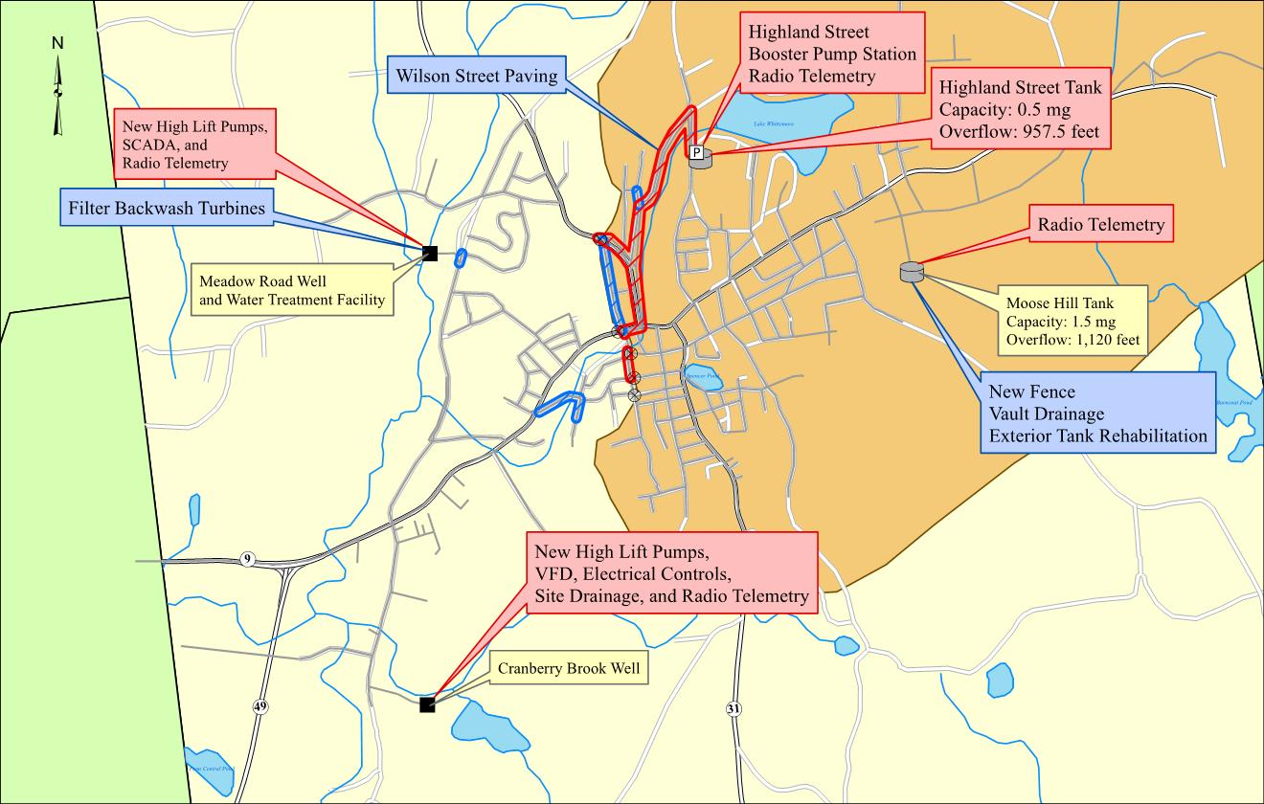

Figure No.5. Completed Highland Street Cast-in Place Tank and Booster Pump Station

